CIDM 6355 LA1 Submission
(40 points in total; Due 11:59pm CST, July 12, 2025)
Your name: Bolaji Muyiwa
Part 1 A Screenshot of Statement of Accomplishment (you should receive a copy in your email as well) to show that you have completed “Introduction to R” or “Introduction to R for Finance” (24 points). Please make sure that your Statement of Accomplishment meet all the requirements specified in LA1 Instruction.



Part 2 RM Preparation Practice (16 points).
- A screenshot of your RM process with date and time and briefly describe what your process is about and what the dataset is about (4 points for Screenshot and 6 points for your two descriptions). Please make sure that your screenshot includes date and time. In your description, you must use the correct terms specified in Getting Started glossary; otherwise, 1 point will be deducted for each incorrect use of a terminology.

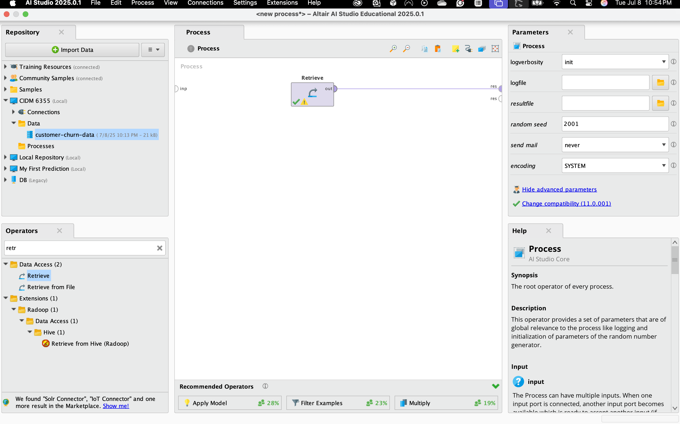
RM Process:
For my RM Process shown above which is a set of interconnected operators, I leverage the use of the “retrieve” operator to manipulate and shows all my data, here using the Retrieve Operator load my data set customer-churn-data.
An operator is building blocks which are grouped by functions to create a process, an operator has input and output ports, for this scenario I used the retrieve operator to retrieve the data set.
In addition, the Retrieve operator load all the object into the process and retrieving the data, the using this operator also provides the meta data of the RM Objects

Dataset:
For my data set the training set and test model is leverage using the Customer-churn-data dataset from an excel file, when imported into the RM, it contains 996 Sets, 1 Special Attribute and 4 Regular Attribute. The Attribute which are also the table column of the data set contain the following
Gender
Age
Payment Method
Last Transaction
Churn (Special Attribute)

Churn, Gender and Payment Method Attribute have the type “Nominal”
Age and Last Transaction Attribute have the type “Integer”

- Take a screenshot of your visualization in RM with date and time and briefly describe what the visualization is about (3 points for Screenshot and 3 points for your description). Please make sure that your screenshot includes date and time. In your description, you must use the correct terms specified in Getting Started glossary; otherwise, 1 point will be deducted for each incorrect use of a terminology.

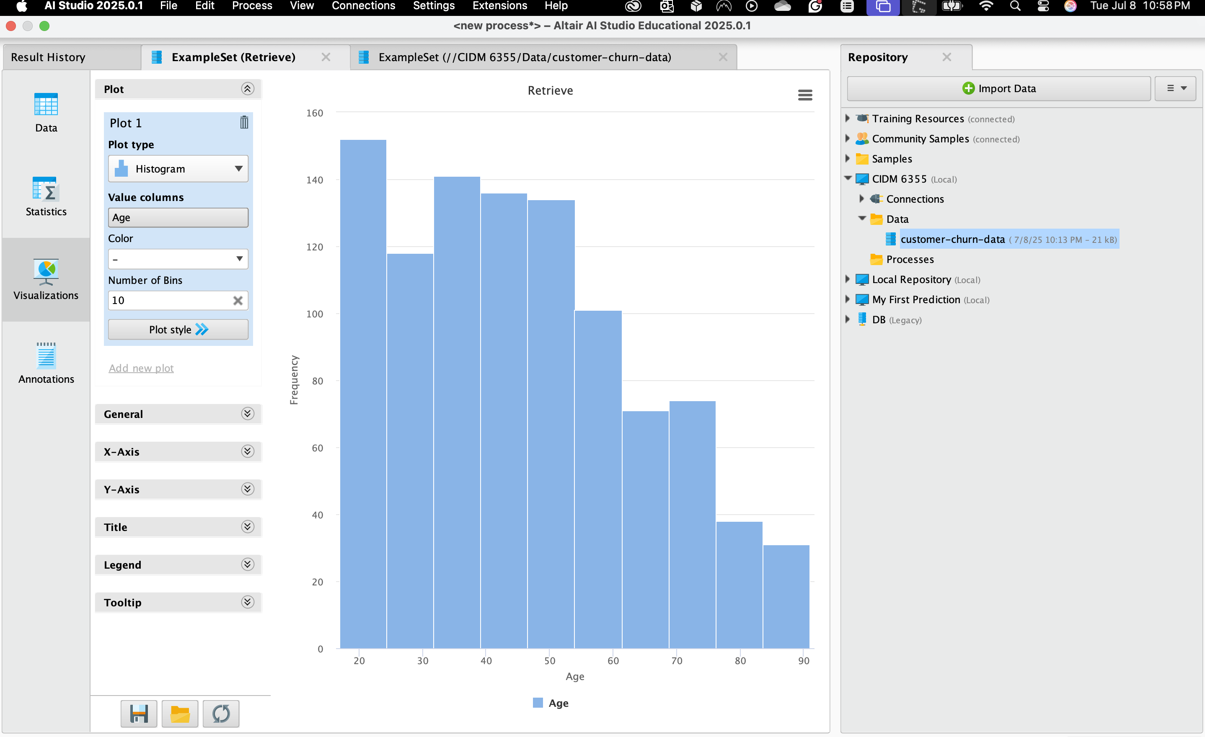

Visualization in Rapid Miner is presenting results in a self-organizing map
The Visualization above for my data set “Customer-Data-Churn” has a plot type “Histogram” for the Value Column “Age” with the Number of Bin as 10.
Here its shows that the Age group 17-24 with the count of 152 has the highest churn rate with the Age 84-91 having the lowest churn rate and tend to be a loyal customer, interestingly age group 24-32 tends to have a lower churn rate compared to Age group 32-54.

